The Denver International Airport (DIA) Automated Baggage Handling Project

Project Charter

Robert Healy, Scott Harpster, Mark Thomasson, Alex Cannell

Feb 1, 2016

Version 1.7

Table of Contents

1.0 Revision History

2.0 Statement of Purpose

3.0 Project Information

4.0 Project Overview

4.1 Overview of the Organization

4.2 Current Situation and Problem/Opportunity Statement

4.3 Project Objectives

5.0 Roles and Responsibilities

6.0 Project Constraints/Risks

7.0 Assumptions

8.0 Preliminary Schedule and Budget Estimates

8.1 Preliminary Schedule

8.2 Preliminary Budget

9.0 Plan Modification Rules

10.0 Approval Signatures



# 1.0 Revision History

|  |  |  |  |
| --- | --- | --- | --- |
| Name | Date | Reason For Changes | Version |
| Scott Harpster | 02/11/2016 | Formatting | 1.7 |
| Project Team Revision | 02/10/2016 | Amending Budget and Schedule | 1.6 |
| Alexander Cannell | 02/09/2016 | Amended sections 5.0 and 6.0 | 1.5 |
| Rob Healy | 02/07/2016 | Fixed formatting on section 10. Added to sections 8 and 9 | 1.4 |
| Mark Thomasson | 02/07/2016 | Amended sections 4.2 & 4.3 | 1.3 |
| Scott Harpster | 02/06/2016 | Fixed Table Format Worked on Statement of Purpose | 1.2 |
| Alexander Cannell | 02/06/2016 | Implementing Roles and Responsibilities | 1.1 |



# 2.0 Statement of Purpose

The purpose of this document is to formally recognize the authorization of The Denver International Airport (DIA) Automated Baggage Handling Project. This document contains (a) general information about The Denver International Airport (DIA) Automated Baggage Handling Project, (b) a project overview, (c) the project objectives, (d) a list of the people involved in The Denver International Airport (DIA) Automated Baggage Handling Project, (d) a list of project constraints, (e) any assumptions made, (f) the preliminary schedule and budget estimates, (g) the plan modification rules, and (h) an approval signature section.



# 3.0 Project Information

|  |  |
| --- | --- |
| Project Start Date: | March 1st, 2016 |
| Project End Date: | March 1st, 2023 |
| Project Manager: | Scrooge McDuck |
| Project Sponsor: | Michael Huetra - Federal Aviation Administration |



# 4.0 Project Overview

## 4.1 Overview of the Organization

The Denver International Airport (DIA) has over 53 million passengers on its busiest day with over 153 gates. Our top priorities at DIA are the safety and security of our customers, that our flights leave on time and arrive on time, and all our customers have a good experience at DIA. We achieve these goals by trainings our employees, maintaining our systems, hiring security specialists and skilled professionals.

Automated Baggage Handling Project will be a huge benefit to our customers as they check in their luggage and pick up their luggage. The speed increase in handling baggages will provide a faster turnaround time and be more efficient for flights and passengers. It will also allow room for more passengers and growth.

## 4.2 Current Situation and Problem/Opportunity Statement

There was a desire to put in place an automated baggage handling system to coincide with opening of Denver International Airport. The initial project was fraught with issues and finally scrapped by the lone carrier – United - that adopted it. Denver International Airport has returned to a manual baggage handling system. The issues that led to the failure of the initial project need to identified and understood before exploring the benefits of a second attempt at implementing an automated baggage handling system.

There were many issues with the initial project. Some of the issues with the initial project may not still be valid today. Other issues that affected the initial project need to be taken into consideration with the new project. Below is a listing of the issues identified in a postmortem of the original project.

· Estimates of Complexity – there was a desire to have a state of the art automated baggage handling system, however those involved in the original project grossly underestimated the complexity needed to deliver the project

· Time Constraints – those involved with the project also grossly underestimated the time needed to deliver the project. At the time, much smaller and less ambitious automated baggage handling projects in San Francisco and Munich took two years to complete. Given the quantum leap in terms of size and complexity, completing the Denver system in two years was an impossible task.

· Airport Opening – the delivery of an automated baggage handling system was a prerequisite for the initial opening of the airport. With the initial failed automated system already replaced by a manual baggage handling system, the initial pressure and time constraints may not be as valid today as they were with the initial project.

· Stakeholders – One of the key failures of the initial project was not engaging all of key stakeholders that would be involved in the project. Because earlier generation baggage facilities were dedicated to individual airlines, airlines had historically built their own systems when a new airport was built. The advent of the integrated airport wide system required a change in mindset. The primary oversight was not engaging all of the airlines.

· Initial allowances for project planning – Because there was such an accelerated timeline with the initial project, the proper time necessary for the foundational planning and discovery did not take place. The initial project planner only had three working sessions before the start of the project. “The three working sessions did not have provide sufficient time for the different parties to develop an in-depth understanding of what was involved or for them to fully understand the risks they were taking.“

· Allowances for changes – Because the initial project was on such a tight timeline, there was little allowances that could be made for the invariable changes that arose with a project of this size and complexity.

· Phased implementation- Due to the accelerated timelines and the pressure to deliver the automated system so the airport could open, those involved with the project didn’t have the luxury of a more steady phased implementation of the proposed automated system. If they had they could have better accounted for issues with oversized baggage and skis that plagued the initial system.

· Risk management – proper risk management was never fully performed. A glaring example of this was power fluctuations that caused the initial system to crash. Some have argued issues like this would have been better identified and accounted for if proper risk management had taken place.

· Cost - There was a related oversight in underestimating the overall cost of the project. The goals of the initial projects were fairly ambitious. The initial proposition of an automated baggage handling system was for long term cost saving. The final product didn’t realize the cost savings envisioned. When the maintenance costs grew to a million dollars a month, the automated system was scrapped for a manual system.

The potential benefits of an automated baggage handling system remain to this day. Automated baggage handling systems still offer the same operational efficiencies that were proposed in the initial system years ago. The initial system was viewed as a potential labor cost saving for United. With the Airline industry reaping record profits due to historically low fuel prices, there is an opportunity for them to revisit and invest in a properly planned automated baggage project so they might realize long term labor cost savings in this area.

To deliver the benefits of automated baggage handling an exhaustive cost benefit analysis will need to be performed between the current manual baggage handling system and the proposed automated system.

## 4.3 Project Objectives

The goals of the proposed automated baggage system will increase the operational efficiencies of the baggage handling process while reducing the associated costs both labor and operational.



# 5.0 Roles and Responsibilities

|  |  |  |  |
| --- | --- | --- | --- |
| Name | Role | Position | Contact Information |
| Scott Harpster | Project Team Lead | IT Specialist at Automated Systems Inc. | scott.harpster@gmail.com |
| Alexander Cannell | Project Team Lead | Lead Systems Analyst at Automated Systems Inc. | cannell.alexander@gmail.com |
| Mark Thomasson | Project Team Lead | Systems Administrator at BAT Automated Systems Inc. | markthomasson02@gmail.com |
| Rob Healy | Project Team Lead | IS Manager at BAT Automated Systems Inc. | roberthealy@suumail.net |
| Scrooge McDuck | Stakeholder | President of BAT Automated Systems Inc. | Scroogy@money.org |
| Michael Hancock | Stakeholder | Denver Mayor | mhancock@denvercity.gov |
| Gail Edmond | Head of the DIA Project Team | DIA Administrator | gedmond@DIA.org |
| Mattias Franz | Consulting engaged to evaluate the project | Logplan Consulting of Germany | mfranz@logplan.gr.org |
| Michael Huetra | Stakeholder | Federal Aviation Administration Administrator | mhuetra@faa.gov |
| James Swenson | Stakeholder | CEO of BTR P.L.C | jswenson@btr.org |
| Stephen Wolf | Stakeholder | United Airlines Administrator | swolf@unitedair.org |
| Gordan Bethune | Stakeholder | Continental Airlines Administrator | gbethune@continental.org |
| Richard Anderson | Stakeholder | Delta Airlines Administrator | randerson@delta.org |
| Keith Williams | Stakeholder | British Airways Administrator | kwilliams@britishair.org |
| Gary Kelly | Stakeholder | Southwest Airlines Administrator | gkelly@swair.org |
| Andrés Conesa | Stakeholder | Aeromexico Administrator | aconesa@aero.org |
| Calin Rovinescu | Stakeholder | Air Canada Administrator | crovinescu@aircanda.org |
| Bradley Tilden | Stakeholder | Alaska Airlines Administrator | btilden@alaskaair.org |
| Doug Parker | Stakeholder | American Airlines Administrator | dparker@AA.org |
| Robin Hayes | Stakeholder | JetBlue Airways President | rhayes@jetblue.org |



# 6.0 Project Constraints/Risks

**The Scope:**

The whole Denver International Airport is having their baggage handling system automated; Denver International Airport is the 15th busiest airport, with more than 53 million passengers passing through each year, and generating an annual regional revenue of over $26 Billion. The scope of this project is huge, with the amount of resources, manpower, money, planning, and hours going into this project will be astonishing. There is an expectation of some constraints and some risk with a project of this size and magnitude. There is going to be impact on almost every part of the airport because the baggage handling system is a core part of the airport.

**The Schedule:**

In the preliminary schedule there is currently just under 6 total years allocated to complete this project. The obvious goal is to get the project done before the 6 year mark. Going over time on this project will eventually lead to being over budget. Time equals money. To help mitigate the possibility of going over time; on the project management team have scheduled time for testing, planning, research & development, training, and doing the implementation of the baggage handling system in four phases.

**The Budget:**

Our current budget is just under 7 billion. Our goal is of course to stay under budget. There is a high probability of going over budget, to mitigate the risk. keep the project strictly on schedule, making proper training a priority, performing risk assessments annually, and proper communication will all cut costs in the long run.

**The Quality:**

There are three concourses in the Denver International Airport with 33 gates. The project has been split into three phases during the system implementation to keep the other parts of the airports up and running, allows for testing of the new automated system in the different concourses before completion of the full system, prevention of recurring problems, and full understanding on the proposed budget, and schedule are correctly. For each concourse implementation there is an estimate that it will take a year, and an additional 6 months to connect each concourse. Risk management is the process of evaluating the potential risks involved, in order to identify and prevent future impact. Risk management saves companies time and money in a project.

**Impact:**

During the project each of the baggage handling system will be taken down for each concourse; while we work on the automated system. The concourse will still be receiving baggage.This will require manual baggage handling until the automated system for that concourse is up and running. The implementation of a temporary system of manual baggage handling should only have minimal impact on the construction. There is an expectation to see baggage handling on the concourse under construction to be a little bit slower than the other concourses. But the ultimate goal is to increase the whole Denver Airport baggage handling process to under 30 minutes a bag. Also some construction impacts from this project as well which include air, water, disposal of waste, impacts to traffic, noise pollution, and load balancing. Which means implementing plans in a way to limit the impact to travelers, and the airport functionality in general. Another impact will be on security; then security during the project will have to be reevaluated and will require implementation of the new security to accommodate construction on the project.

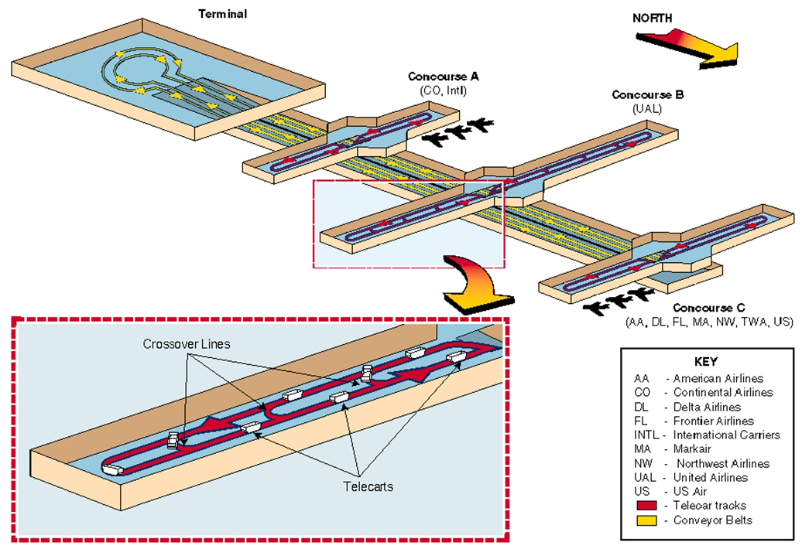



# 7.0 Assumptions

The biggest assumption is that this current project won't make the same mistakes as other previous automated baggage system project failures. Future projects can learn a lot from the past mistakes of the earlier failed project, and know with confidence that things will work out. “Learn from the mistakes of others, you can't live long enough to make them all yourself.” - Eleanor Roosevelt

* Staying within budget
* Project will finish on time
* The project will be completed in phases
* Everyone on the project will be properly trained
* No communication barriers
* An annual risk assessment
* Proper planning
* Proper Training
* Understanding the project will have delays and plan accordingly
* Sticking to short, medium, and long term goals
* Addressing security concerns



# 8.0 Preliminary Schedule and Budget Estimates

## 8.1 Preliminary Schedule

|  |  |
| --- | --- |
| **Phase** | **Time** |
| Identify stakeholders and organize Kickoff meeting | 3 months |
| Planning, Research & Design | 1 year |
| Prototype and testing | 6 months |
| Implementation Phase 1 concourse A | 1 year |
| Implementation Phase 2 concourse B | 1 year |
| Implementation Phase 3 concourse C | 1 year |
| Implementation Phase 4 connect all concourses | 6 months |
| Post Implementation Training & Orientation | 6 months |

## 

## 

## 8.2 Preliminary Budget

|  |  |
| --- | --- |
| **Cost Areas** | **Dollar Amount** |
| Planning | 1,000,000,000 |
| Research and Development | 500,000,000 |
| Prototyping and Testing | 1,500,000,000 |
| Implementation | 2,000,000,000 |
| Materials and Services | 2,000,000,000 |
| Training and Orientation | 500,000 |
| **TOTAL** | **7,000,500,000** |



# 9.0 Plan Modification Rules

* Only the project manager has the authority to change this document
* Changes are only allowed in exceptional circumstances
* Changes can only be considered after all parties involved have met
* All Stakeholders must agree if changes are to be made



# 10.0 Approval Signatures

Project Manager:

As project manager on the Denver International Airport Baggage Handling Project, I have reviewed the information contained in the Project Charter and agree to its content.

|  |  |  |  |
| --- | --- | --- | --- |
| Name | Position | Signature | Date |
| Scott Harpster | IT Specialist at Automated Systems Inc. |  | 02/05/2016 |
| Alexander Cannell | Lead Systems Analyst at Automated Systems Inc. |  | 02/05/2016 |
| Mark Thomasson | Systems Administrator at BAT Automated Systems Inc. |  | 02/05/2016 |
| Rob Healy | IS Manager at BAT Automated Systems Inc. |  | 02/05/2016 |
| Scrooge McDuck | President of BAT Automated Systems Inc. |  | 02/06/2016 |
| Michael Hancock | Denver Mayor |  | 02/06/2016 |
| Gail Edmond | DIA Administrator |  | 02/06/2016 |
| Mattias Franz | Logplan Consulting of Germany |  | 02/11/2016 |
| Michael Huetra | Federal Aviation Administration Administrator |  | 02/04/2016 |
| Jay Bouton | BAT’s Sales Manager |  | 02/04/2016 |
| James Swenson | CEO of BTR P.L.C |  | 02/04/2016 |
| Stephen Wolf | United Airlines CEO |  | 02/04/2016 |
| Gordan Bethune | Continental Airlines CEO |  | 02/04/2016 |
| Richard Anderson | Delta Airlines CEO |  | 02/04/2016 |
| Keith Williams | British Airways CEO |  | 02/04/2016 |
| Gary Kelly | Southwest Airlines CEO |  | 02/04/2016 |
| Andrés Conesa | aeromexico CEO |  | 02/04/2016 |
| Calin Rovinescu | Air Canada CEO |  | 02/04/2016 |
| Bradley Tilden | Alaska Airlines CEO |  | 02/04/2016 |
| Doug Parker | American Airlines CEO |  | 02/04/2016 |
| Robin Hayes | JetBlue Airways President |  | 02/04/2016 |

The signatures above represent stakeholders’ agreement and acknowledgement of the information contained in this document.



**CITED WORKS:**

* Gregor, S. D., & Hart, D. N. (2005). Information Systems Foundations: Constructing and Criticising. ANU E Press. Retrieved from <http://press.anu.edu.au/info_systems/part-ch06.pdf>
* Myerson, A. R. (1994, March 18). Automation Off Course in Denver. The New York Times. Retrieved from <http://www.nytimes.com/1994/03/18/business/automation-off-course-in-denver.html>
* Diabhs Case Presentation Final. (12:06:34 UTC). Retrieved from <http://www.slideshare.net/guestc19f34/diabhs-case-presentation-final>
* DIA Project Failure - A Case Study. (n.d.). Retrieved February 14, 2016, from <https://prezi.com/gazi1mgda8pr/dia-project-failure-a-case-study/>
* DENVER INTERNATIONAL AIRPORT AUTOMATED BAGGAGE HANDLING SYSTEM-PROJECT FAILURE ANALYSIS MSc Project Management. (n.d.). Retrieved February 14, 2016, from <http://www.academia.edu/6732057/DENVER_INTERNATIONAL_AIRPORT_AUTOMATED_BAGGAGE_HANDLING_SYSTEM-PROJECT_FAILURE_ANALYSIS_MSc_Project_Management>
* Uncle Sam’s Dumbest Tech Buys. (2010, November 8). Retrieved February 14, 2016, from <http://www.pcworld.com/article/210029/aa.html>
* Eardley, T. (2013). Chapter 3 Managing the Information Systems Project Modern Systems Analysis and Design Sixth Edition. Retrieved February 13, 2016, from <http://slideplayer.com/slide/1704723/>
* Verkinderen, A. (2014, June 19). Live Maps Unity- Application Scenarios Part I. Retrieved February 13, 2016, from <https://www.savision.com/resources/blog/live-maps-unity-application-scenarios-part-i>
* Barati, S. (n.d.). Introduction to Empirical Modeling. Retrieved from <https://www2.warwick.ac.uk/fac/sci/dcs/research/em/publications/web-em/06/baggage_management_system.pdf>